

Overall

Author: Tyler Lu

Contents

1. Microsoft Teams 2

1.1. Enable Microsoft Teams feature 2

1.2. Choose a user to authorize Logic Apps 2

1.3. After a Team created 3

1.4. Create the global team 4

2. Azure component 4

3. App-only Cert 5

4. Other 5

# Microsoft Teams

## Enable Microsoft Teams feature

Please following the [Enable Microsoft Teams features in your Office 365 organization](https://docs.microsoft.com/en-us/microsoftteams/enable-features-office-365).

Make sure the following options are turned on:

* Allow external apps in Microsoft Teams
* Allow sideloading of external apps

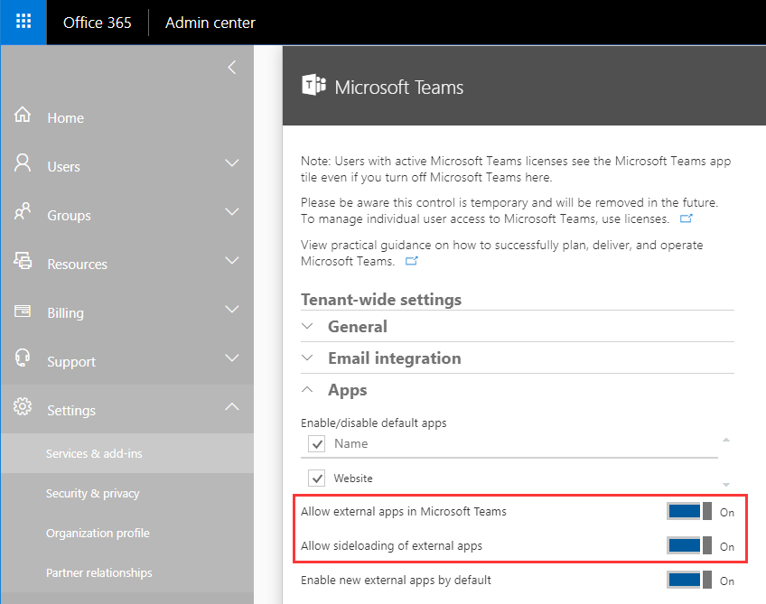

## Choose a user to authorize Logic Apps

A user is required to be in every teams (member is enough), due to the limitation of Microsoft Planer (only delegated permissions allowed).

The user’s credentials will be used to authorize Logic App.

Administrator would be the best candidate.

## After a Team created

1. Active the default planner associating the team and has the same name.

Open <https://www.office.com>, sign in.

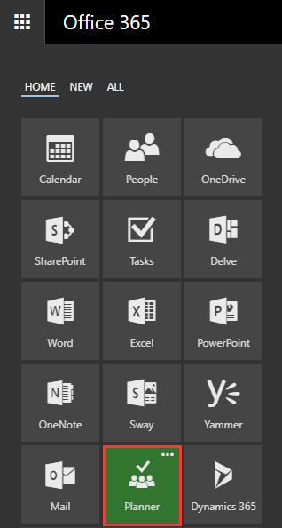

Click the Planner.

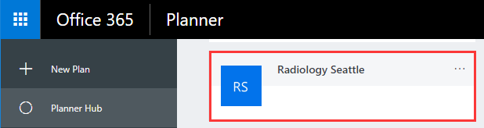

Find the planner which has the same name as the team, then click it.

1. Create the following bucket:
   * New Idea
   * In progress
   * Completed
   * Shareable
2. Add the user mentioned above to the team, if the user is not a member or owner of the team.

## Create the global team

Create a global team, and copy aside its name. The name will be used as **GlobalTeam** App settings of the Metric Web App.

# Azure component

Create a Resource group in Azure

* Name: “Huddle” or other

Create an App Service plan in the resource group

* Operating System: Windows
* Pricing tier: B1

The App Service plan will be used for

* The Metric Web App
* The Bot Web App

# App-only Cert

The next document will create an app-only cert. It will be used by the Metric Web App and Bot Web App.

Please keep it.

# Other

An Azure AAD is required to register the app registrations. Make sure you are the admin of it. From this point of the document on, the Azure AAD will be called "Huddle AAD", and an account in Huddle AAD will be called Huddle work account.

* All app registrations should be created in Huddle AAD.
* Bot/Luis/Microsoft App should be registered with a Huddle work account.
* SharePoint lists should be created on Huddle SharePoint which associated with Huddle AAD.
* Azure Web Apps could be deployed in any Azure subscription.